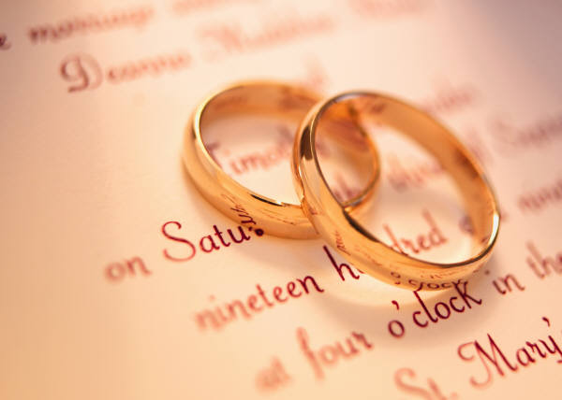

The Wedding Policy of

Circleville Presbyterian Church (U.S.A.)
134 E. Mound Street
Circleville, OH 43113
Telephone: 740-474-4791
www.circlevillepresbyterianchurch.com

“Christian Marriage”

Marriage is meant to be a joyous experience in the fullness of God’s love. The marriage relationship was instituted by God (Genesis 2:24) and was blessed by our Lord Jesus Christ (Matthew 19:5-6). It seems most fitting then, that the church should be the place for your ceremony. We hope that the church fellowship will provide a loving and prayerful atmosphere for the beginning of your lives together. We also hope that if you are not a part of the fellowship at Circleville Presbyterian Church, that you will consider coming and uniting with us. Circleville Presbyterian Church offers a very attractive traditional setting for your wedding ceremony. It is our prayer that the wedding ceremony will be a happy, memorable, and Christ-centered event for you and your families.

The Session and Pastor of this church require you to abide by the following procedures. It is our hope that these procedures will answer many of your questions concerning your wedding ceremony here at Circleville Presbyterian Church.

- The officiating pastor will establish with each couple a schedule of pre-marital counseling sessions. The couple should make arrangements well in advance to meet with the pastor. All weddings must be approved by the Session of Circleville Presbyterian Church.

- The pastor will schedule all rehearsals. The pastor maintains the right to either permit or deny individuals from attending the rehearsal or wedding ceremony.

- The marriage license must be given to the pastor at the time of your rehearsal. This allows time for proper completion of your marriage license.

- A wedding coordinator will be provided by the church for your use. Any outside wedding coordinator must work with the guidance of the church wedding coordinator.

- We request the use of our church musicians for your wedding ceremony. Please make arrangements with one of our church musicians well in advance. Outside musicians are permitted with the approval of the pastor in concurrence with our church musicians.

- All music for your wedding must be discussed with both the pastor and the church musician if used.

- During the actual wedding ceremony, only non-flash photography is allowed. No one is permitted to stand in the aisle and take photos as the bridal party processes. This blocks the view of the groom and the immediate family. Video cameras are permitted, but only with the pastor’s approval of location during the ceremony.

- When decorating the church, please do not use thumbtacks or tape. Bows from the pews may be hung with rubber bands or pipe cleaners. Seating capacity of the church is approximately 275 people.
  - Candelabras are available (you must provide your own non-drip candles).
  - A unity candle may be used on the communion table. (One is available for use at the church, but you may choose to purchase your own.)
  - The aisle in the sanctuary is approximately 25 feet long. This will help select the size of the aisle runner the couple will need to purchase if desired.
  - A kneeling bench is available for use.
  - Please notify the church office of the items you wish to use.

- We do not allow alcoholic beverages or smoking on the church property. Please restrict the use of food and beverages to designated areas.

- Please remember that your wedding will call for a moderate clean-up, both before and after the ceremony. Custodial services will be required and provided by the church
- Please arrange with the wedding coordinator for early entry into the church for the rehearsal and the wedding.
- No rice, confetti, balloon release or birdseed can be used on any part of the church property. We suggest bubbles outside of the building to celebrate the marriage.

Fees and Suggested Honoraria
Every effort is made to assist in keeping the cost for a wedding at a minimum. There are, however, some costs which the church is not able to assume.

Members Non-Members
1. Use of Church(fee) No Cost $500.00
2. Use of Social Hall(fee) No Cost $200.00
2. Pastor No Cost $300.00
3. Musician $125.00 $125.00
4. Custodial Services $125.00 $125.00
5. Wedding Coordinator No Cost $75.00
6. Media Technicians $75.00 $75.00

*Make checks payable to Circleville Presbyterian Church for “Use of Church” and “Use of Social Hall”. All other suggested honoraria above should be made payable to the named individual at the time of the wedding.
All fees are due at the Rehearsal.

If you have any questions regarding these procedures, please feel free to call Circleville Presbyterian Church.
Revised September 2017

